

**Nature Valley Homestay Billing System**

**Software Requirement Specification (SRS) Document**

**Sprint 1 Implementation**

**Project Timeline: 22.09.2022 to 10.10.2022**

**INDEX**

1. Introduction

1.1 Purpose -------------------------------------------------- 4

1.2 Intended audience -------------------------------------------------- 4

1.3 Intended use -------------------------------------------------- 4

1.4 Scope -------------------------------------------------- 4

2. Overall description -------------------------------------------------- 5

2.1 Assumptions and dependency -------------------------------------------------- 5

3. System feature and requirements -------------------------------------------------- 5

3.1 Functionality -------------------------------------------------- 5

3.1.1 Menu Driven Application ----------------------------------------------- 5

3.1.2 Customer Database -------------------------------------------------- 5

3.1.3 Bookings Database —----------------------------------------------- 5

3.1.4 Check-ins & Check-outs -------------------------------------------------- 5

3.1.5 Rooms Database -------------------------------------------------- 5

3.1.6 Bill Book -------------------------------------------------- 5

3.1.7 Bill Id -------------------------------------------------- 6

3.1.8 Calculate Total Bill ------------------------------------------------ 6

3.1.9 Base Room Fare -------------------------------------------------- 6

3.1.10 Validations -------------------------------------------------- 6

3.1.11 Validations -------------------------------------------------- 6

3.2 System requirement -------------------------------------------------- 6

3.2.1 Tools to be used -------------------------------------------------- 6

3.3 System feature ------------------------------------------------ 6

4. Design Diagram

4.1 Use Case Diagram ------------------------------------------------ 8

4.2 Class Diagram ------------------------------------------------ 10

4.3 Sequence Diagram ------------------------------------------------ 11

### **1.** **Introduction: -**

The introduction of the software requirement specification provides an overview of the entire software. The entire SRS with overview description purpose, scope, tools used and basic description. The aim of this document is to gather, analyze and give an in-depth insight into the complete Nature Valley Homestay Billing System application by defining the problem statement in detail. The detailed requirements of the Nature Valley Homestay Billing System application is provided in this document.

**1.1** **Purpose**: **-**The purpose of this document is to show the requirements for the Nature Valley Homestay Billing System application, in which the application is to be developed for automating the billing process for the resort and maintaining the bill book.

**1.2** **Intended Audience: -**This document is intended to be read by, Client.

**1.3** **Intended Use: -**

* Development Team
* Maintenance Team
* Clients

Since this a general-Purpose Software any one can access it.

**1.4** **Scope: -**This project aims to create the development of a Nature Valley Homestay Billing System application. It is a menu driven program to manage customers, bookings, check-ins, check-outs and the bill book. The customer, bookings and check-ins databases are maintained in text files. The input entries are validated for the number of days and people per room. The invalid entries get stored and display a console message.

**2. Overall Description: -**

It is a Nature Valley Homestay Billing System application which is used to automate the billing process for the resort and maintain a bill book. It is a menu driven program to manage customers, bookings, check-ins, check-outs and the bill book. Application maintains the customer and booking database in text files which can be updated using customer-ID and booking-ID. The check-ins and check-outs database is also maintained in text files which can be updated by the admin using booking-ID. The Bill Book database is also maintained. Once the bill is paid it can be updated, the bill should be displayed at the time of check-out. Input entries are validated people per room, and days of booking, the invalid entries are stored in a text file. The main purpose is to automate the process of billing for Nature Valley Homestay .

**2.1 Assumptions and Dependency: -**

* System should have Ubuntu Linux installed.
* · System should have either 4GB or more RAM.
* The service is used preferably on a desktop or laptop.

**3.System Features and Requirements: -**

**3.1 Functionality: -**

**3.1.1 NV_01-> Menu Driven Application**: We implement a two level menu to run the application with options like Manage rooms, customers & guest reports.

**3.1.2 NV_02-> Customer Database**: The customer data is stored in text files eg:- customer name, id, id-proof, address, room type, check-in date.

**3.1.3 NV_03-> Bookings Database**: The bookings database is maintained for advanced bookings, we store the customer details and the check-in date.

**3.1.4 NV_04-> Check-ins & Check-outs**: We maintain the check-in & check-out function to add & delete customers to the database and we also update the bookings database; the check-out function is also used to calculate the bill.

**3.1.5 NV_05-> Rooms Database**: We store the room's details in a text file & when the program is started we read the room details from this text file .

**3.1.6 NV_06-> Bill Book**: The application maintains a bill book and can also generate a bill report & bill for a customer using room no., customer name, days of stay & total bill.

**3.1.7 NV_07->** **Bill Id:** We generate an id no. for every bill called bill-id, it is stored with every bill & is also displayed when we display the bill.

**3.1.8 NV_08-> Calculate Total Bill:** The application calculates the total bill amount using the type of room, no. of days,& extra guests for each room.

**3.1.9 NV_09-> Base Room fare:** We have 3 types of rooms in the resort and we use the following fares for each type. Standard-2500, Deluxe-3500, Cottage-5500. The fare is for per day.

**3.1.10 NV_10-> Validations:** We perform the following validations before storing the customer or check-in. No. of extra guests should be less than 2. No. of days should be less than 15. The dates & room types should be validated.

**3.1.11 NV_11-> Invalid Entries:** The Invalid entries from text files & Invalid entries from the console should be stored in the invalid entry file .

**3.2 System Requirements: -**

### **3.2.1. Tools to be used:**

* Pthread Library
* C Unit Library
* C File Handling
* C Language
* System Programming

### **3.3 System Features: -**

### Supportability:The system is easy to use.

* Design Constraints: The system is built using only C language.
* Usability:The Nature Valley Homestay Billing System application can be used to replace the old means. The system can be used by Nature Valley Homestay resort, the system will automate the billing process and maintain a bill book.
* Reliability & Availability**:** The system is available 24/7 that is whenever the user would like to use the system, they can use it up to its functionalities.

### Performance: The system will work on the user’s terminal**.**

**4. Design Diagram:**

**4.1 Use Case Diagram -**

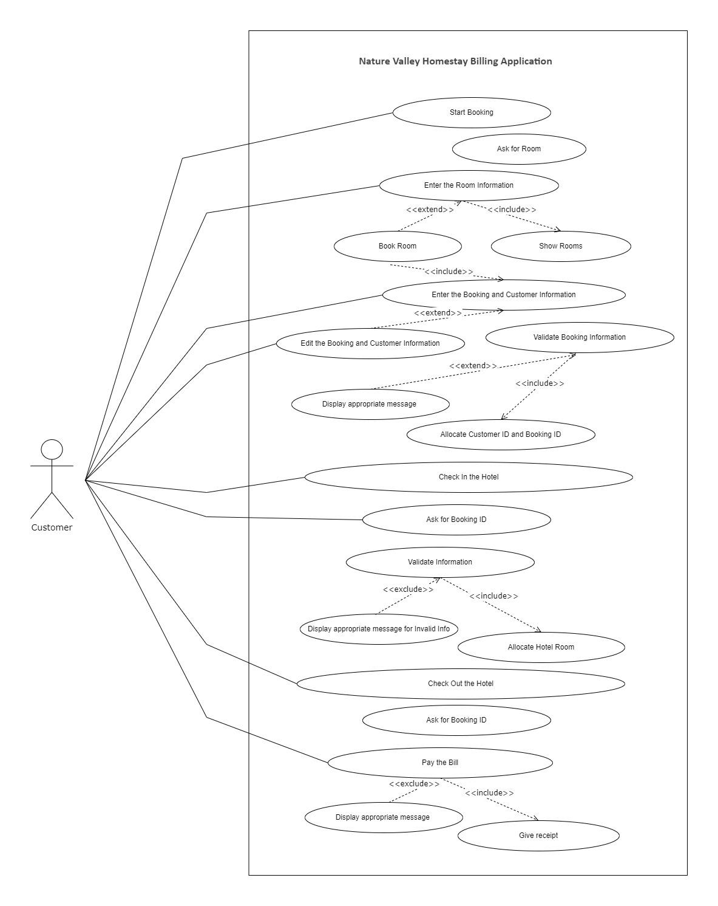

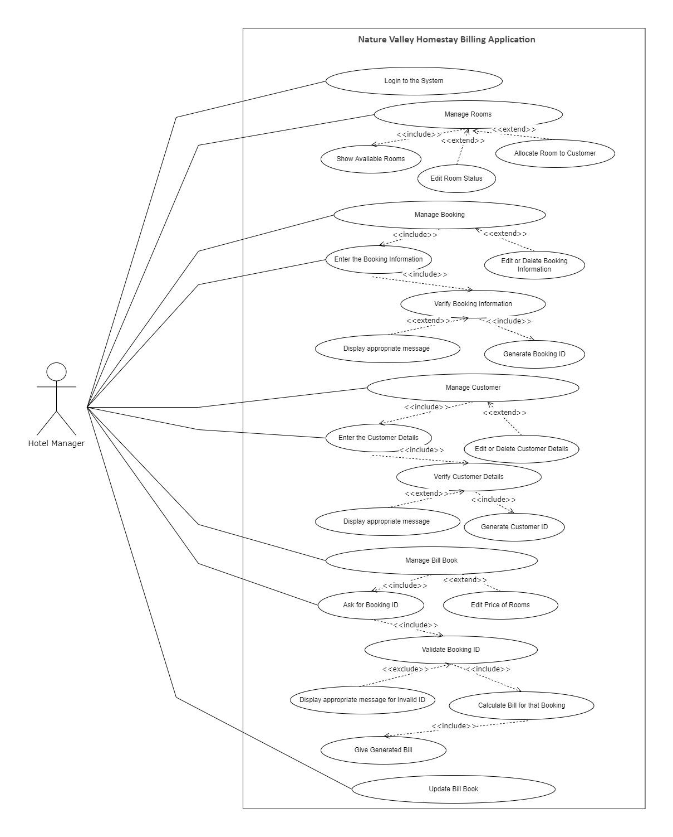

**4.2 Class Diagram**

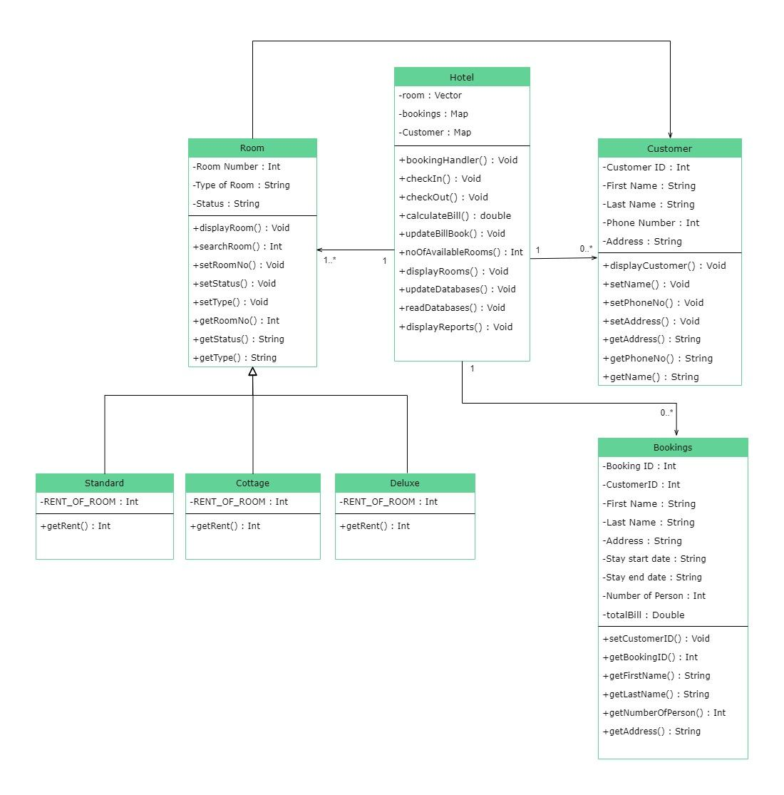

**4.3 Sequence Diagram**

